2022

Omar Ali

Epsilon

1/1/2022

Car Insurance

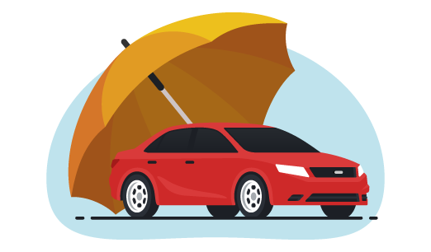

**About Dataset:**

**The company has shared its annual car insurance data. Now, you must find out the real customer behaviors over the data. This is customer data with their vehicle insurance policies. Details about customers and the insurance taken for their vehicles are provided which can be explored to segment similar kinds of customers.**

**From Kaggle:** [**https://www.kaggle.com/datasets/sagnik1511/car-insurance-data**](https://www.kaggle.com/datasets/sagnik1511/car-insurance-data)

**Data Contains:**

**10000 Rows**

**19 Columns**

**Features:**

1. **ID: To Identify the Persons**
2. **AGE: From 16 To 65+**
3. **GENDER: Male, Female**
4. **RACE: The majority**
5. **DRIVING_EXPERINCE: From 0 To 30+**
6. **EDUCATION: The Education a Person has Received**
7. **INCOME**
8. **CREDIT_SCORE: a Number Rate a Consumers Creditworthiness**
9. **VEHICLE_OWNERSHIP**
10. **VEHICLE_YEAR**
11. **MARRIED**
12. **CHILDREN**
13. **POSTAL CODE**
14. **ANNUAL_MILEAGE: The Number of Miles You Drive Each Year**
15. **VEHICLE_TYPE**
16. **SPEEDING_VIOLATIONS**
17. **DUIS**
18. **PAST_ACCIDENTS**
19. **OUTCOME**

**Question Analysis:**

1. **Is There a relationship between driving_experince and outcome**
2. **What is the maximum outcome per gender**
3. **Is there a relationship between education and outcome**
4. **Is there a relationship between income and outcome**
5. **Is there a relationship between age and outcome**
6. **What is the maximum outcome per age**